Aliza Shahzad

Arduino Program Analysis

1. This program, at high level, controls the duration and brightness of three pins (red, green, and blue) using the serial console.
2. Section 1- Defines where each pin in connected on the Arduino board. In this code, the redPin is D3, the greenPin is D5, and the bluePin is D6.

Section 2- This is where the pins are said to be in a low-impedance state, meaning that they are providing current to other circuits.

Section 3- Each pin is looking for the next valid integer in the incoming serial stream.

Section 4- The range of brightness for each pin (how bright the pin is when it lights up).

Section 5- An analog value (PWM wave) is given to the pin.

Section 6- This is the last part of the code. It prints data to the serial port as human-readable ASCII text. HEX refers to hexadecimal format.

1. On Page 2

|  |  |
| --- | --- |
| **OUTPUT** | **Meaning** |
| Red Light | * the red light is turned on * the constrain range (0, 225) fades the light |
| Green Light | * the green light is turned on * the constrain range (0, 225) fades the light |
| Blue Light | * the blue light is turned on * the constrain range (0, 225) fades the light |

|  |  |
| --- | --- |
| **INPUT** | **Meaning** |
| The word “red” | * turns the red pin on * fades the light using the constrain range (0, 225) |
| The word “green” | * turns the green pin on * fades the light using the constrain range (0, 225) |
| The word “blue” | * turns the blue light on * fades the light using the constrain range (0, 225) |

1. An example of a console input that would cause the program not to work properly would be a number, a letter or a symbol (!, ?, etc.). These are invalid values and do not define the different pins. Only the name of the colours (red, blue, and green), are valid.

Diagram

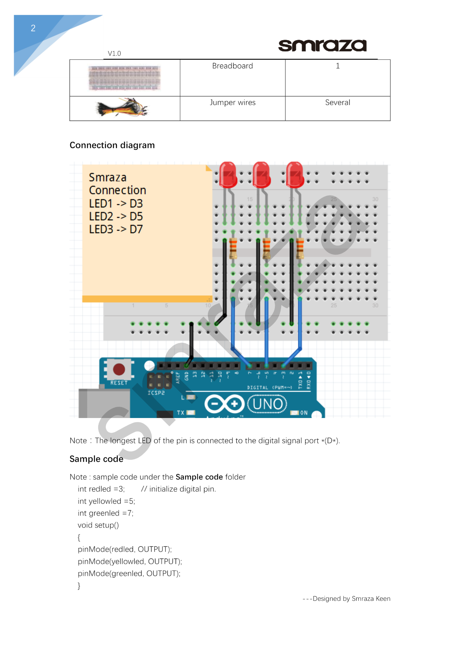

D6

**This is an accurate diagram of the code provided exept that the LED pin connected at 7 shoud be connected at 6 (what the black arrow is pointing to)